School vision for the teaching of Latin
We believe that learning a foreign language provides a valuable educational, social and cultural experience for our pupils. The study of a language is seen as an important part of our pupils’ education as languages are part of the cultural richness of our society and the world in which we live and work. Our aim is to enrich our pupils’ experiences and broaden their knowledge and understanding of the world around them, and their place in it. It is important to understand the links between languages and the diversity they support. We have chosen Latin as our preferred language as the origins of words in many languages are based in Latin, including German, Italian, French, Spanish and English.
Pupils should be introduced to new vocabulary to extend their knowledge of the World around them to start their journey of life-long language skills acquisition. Not only does this enthuse our children with a love of languages, it also inspires confidence in their language and communication skills, learning collaboratively with one another.
We aim to allow our children to gain an insight into how languages in our world have developed over time. Children will nurture a growing appreciation of other cultures and a natural curiosity for the world around them. Our vision is to inspire our pupils to embrace diversity and envision a world in which they can live in harmony with other cultures, creating inquisitive, tolerant and understanding minds of the future.

Latin
Latin at Holy Family Catholic Primary School
We aim to ensure that the children at Holy Family receive a fully rounded education which takes into account of the importance of Latin in the wider world. Latin is taught as a discrete lesson but is used and linked, where possible, with other subjects.
We use the Minimus study books and resources and an insight can be found at the following website address

http://www.minimus-etc.co.uk/
Even a brief encounter with the ancient world not only fires the imagination of the young but also sheds a dazzling light on why we in the West are as we are, with all our massive strengths and disastrous failings.
For generations a classical education was considered a privilege for the few, not the many, but now its revival in primary and secondary state schools is well under way. Classical subjects equip pupils with grammar, critical thinking and language skills.
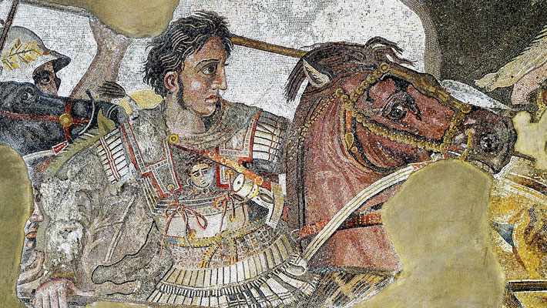
This is because teachers know that studying classics:
- Develops English literacy: students of Latin or Ancient Greek achieve a deep understanding of grammar which encourages accurate use of language. From the very early stages, concepts of singular and plural, tenses and case usage are taught. In GCSE Latin or Ancient Greek, more complex grammatical structures are introduced than those in modern foreign language GCSEs.
- Aids cultural literacy: Classical mythology forms the bedrock of much modern art and literature, and is constantly reworked in theatre and in the visual arts, film and pop-culture.
- Teaches the foundations of philosophy and history: The ancient Greeks and Romans have profoundly influenced western society and thought. They established the disciplines of philosophy and history and the foundations of our political systems.
- Encourages cultural insight: In some ways, the ancient Greeks and the Romans seem just like us, but in other ways, they are very different. This can lead students to reflect deeply about themselves and the lives of others – an important quality in a modern, multi-cultural society.
- Gives opportunities for wide-ranging thinking: Classical subjects encourage students to cross subject boundaries through thinking that touches on language, literature and civilisation.
- Allows for depth and breadth: The study of classical subjects is interdisciplinary. All four classical subjects – Latin, Ancient Greek, Classical Civilisation and Ancient History – can involve literature, history, philosophy and the visual arts.
- Improves employment opportunities: Evidence suggests that employers have respect for potential employees who have studied classical subjects at school or university. Many Classics graduates have made a name for themselves in various fields, including JK Rowling, Boris Johnson and Mark Zuckerburg. This is because, among other things, the study of Classics encourages clarity of thought, attention to detail, and the ability to argue a case.
How Latin has been used over time?
Through the centuries, the works of Homer, Sophocles, Virgil and Ovid have profoundly influenced Britain’s greatest writers, dramatists and poets, including Chaucer, Milton and Shakespeare.
The examples set by Pythagoras, Archimedes, Euclid, Ptolemy, Lucretius and Vitruvius continue to inspire scientists, engineers, architects and astronomers around the world.
Plato and Aristotle established the foundations of western philosophy and political thought; Herodotus, Thucydides, Tacitus and Plutarch invented the arts of the historian and biographer.
The lives of great men and women such as Alexander, Hannibal, Caesar, Cleopatra and Constantine teach us lessons in leadership, power and downfall.

Classics for All
Find out why you should support Classics for All and why pupils and teachers believe that learning classics is valuable.
Click here for Dr Peter Jones MBE on ‘Why Classics’

